Unknown: B
Grace Thomas
11/26/23
CHEM 2081-007

Introduction
The goal of this experiment is to identify an unknown compound, in this case unknown B, through the use of spectroscopy. There are several things that help in the identification of an unknown such as Nuclear Magnetic Resonance (NMR), Fourier Transformed Infrared (FTIR), and Gas Chromatography Mass Spectroscopy. These tests help in the identification of an unknown by giving the functional groups, percentage compositions, and other data of the unknown compound.
This is an important skill for many reasons. Spectroscopy is very applicable to chemistry because it can confirm the identity of a substance formed during an experiment. These tests are a way to ensure that you have obtained the correct end product. However, this process is not just used for identifying final products in a chemical reaction. NASA uses spectroscopy to understand how stars and black holes produce light and to understand what elements they are made of. Scientists use it to improve drug effectiveness, and to understand the different components of a substance. This is a valuable tool that is applied to a wide range of fields and is constantly used to further our understanding of the unknown.

Body
Spectroscopy is known to be applied to atoms and molecules in the liquid, gas, and solid phase by observing their admission, absorption, and electromagnetic cation properties. This is true but it is a very broad idea of spectroscopy, each kind helps to ID and unknown in its own unique way.
Nuclear magnetic resonance spectroscopy uses a large amount of electromagnetic radiation to excite hydrogen and carbon atoms. This excitement eventually fades or “decays” leaving a curve that is converted into a spectrum that can be read as “normal”. NMR is preformed using a superconducting electromagnet that must be kept cool at all times (Figure II-4 in the Lab Manual). There are four kinds of information that can be read from an NMR Spectra including different varieties of protons, number of protons (integration), chemical shifts in the protons, and patterns of spin-spin coupling.
Integration, or number of protons, is determined by the height of each spiked group on an NMR. The chemical shift is found by comparing the number of protons to the intensity of magnetic field. If there is only one spike it is absorbed at the same frequency as the magnetic field but if there are more their absorption is different. These chemical shifts are very important to NMR spectroscopy. The effects of a proton on a chemical shift can be altered based on how shielded or de shielded a proton is from its electron density. There are established values for certain bonds to identify an unknown NMR, for example methyl is 0.9 ppm. The process of NMR is extremely important in chemistry and can be used to identify multiple features of a compound through spectroscopy.

Fourier transformed infrared spectroscopy is also used to identify organic molecules. This type of infrared spectroscopy is vital in identifying unknown compounds because of its unique ability to show what functional groups are present in a molecule. This process plots wavelength and absorption on a graph to be read. IR uses the right amount of energy to absorb compounds covalent bonds to bend or stretch them, this is known as vibrational spectroscopy.
FTIR measures these vibrations and plots them on a graph that is used to identify the compounds functional group based on the wave shape and length on the graph. There are four things that determine and strength and frequency of these peaks. Type of vibration, bond strength, atomic mass, and electronegativity difference. All these factors mean that no two compounds will create the same FTIR spectra. Certain functional groups reside at specific wavelength ranges on an IR spectrum. This can be used to identify the pieces of a compound by assigning certain bonds to specific regions and wavelengths of the spectrum.
The functional group region (4000-1500 cm) is the area where most major functional groups reside. If two groups are in the same region they can be further identified by their peaks. The fingerprint region (1500-900 cm) has many vibrations that appear within its area and gives detailed structural information. The final region is the aromatic region (900-600 cm) mainly gives information on alkenes. Different functional groups will graph in different ways. For example, alcohols appear between 3500-3200cm and have a broad, curved, u shaped structure. Each functional group displays similar unique characteristics that can be used to identify them for FTIR.

Gass chromatography mass spectrometry separates ions by their mass and charge ratios. It sorts the ions and creates a mass spectrum as pictured below. GCMS utilizes a gas chromatograph to send a stream of the original molecule into the mass spectrometer. They are then ionized, analyzed, and graphed. This method of spectroscopy is especially useful for analyzing mixtures of compounds. It shows the approximate amount, type, and identity of each compound in the mixture.
Ions are passed through a magnetic Spector mass analyzer and achieve stable oscillation based on their z ratio. This method is used largely in chemical laboratories. The collected data is presented in a graph where intensity is on the y axis and m/z values are on the x-axis. The most intense peak on the graph is the major component of the base peak of the molecule. If the compound doesn’t fragment you can learn its mass based on the z in m/z. A few rules can help identify a compound that has been put through GCMS. The rule of 13, nitrogen rule, and M+1/M+2 rule all contributes to identifying an organic molecule. When there are several atoms of the same element present probability and isotope abundance help determine the intensity of the ion peaks. These three forms of spectrometry are vital to identifying unknown organic compounds.

Data
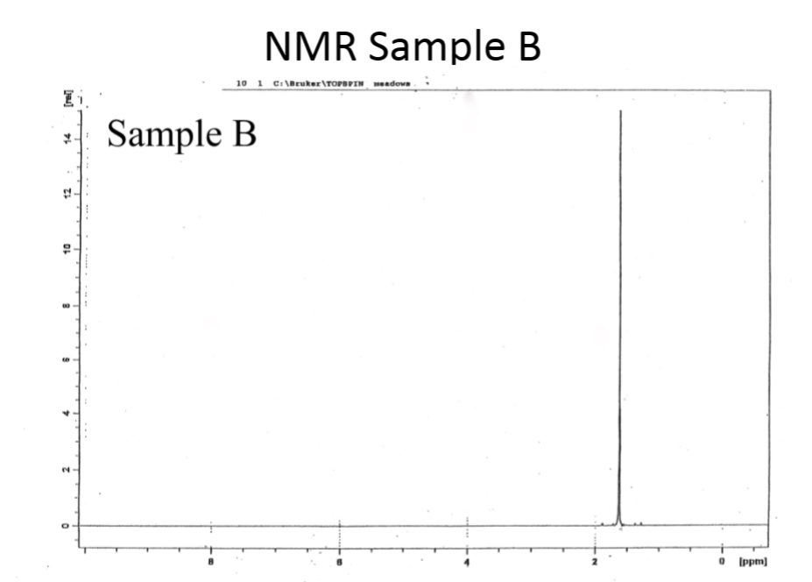

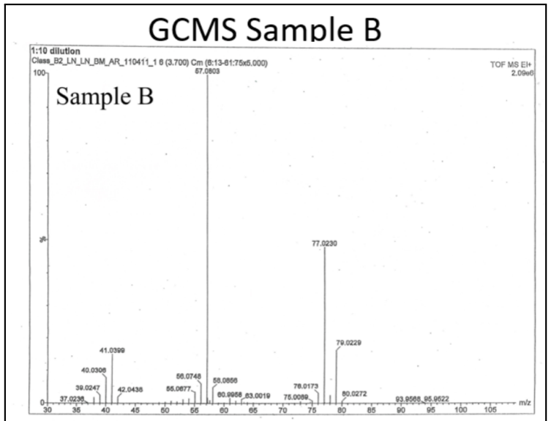
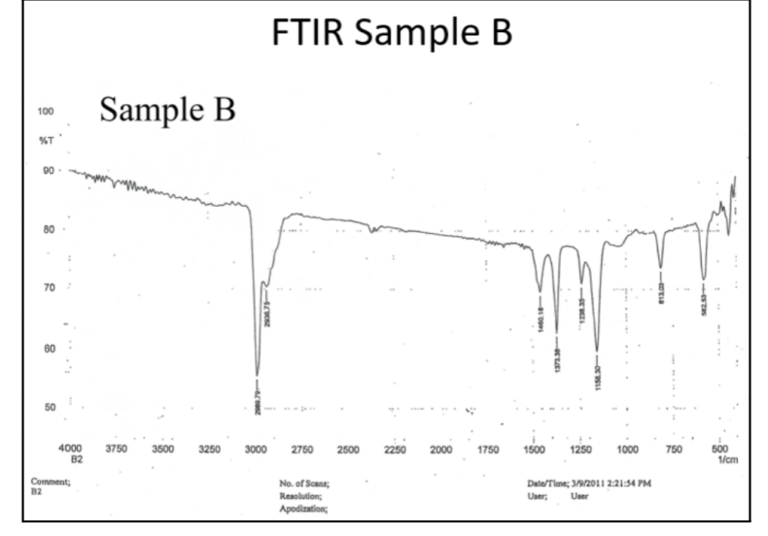
Analysis
To identify Unknown B each of the above graphs was studied. To begin NMR was used because it was very unique with only one singlet spike at 1.8 ppm. This shows that there are no surrounding protons, so it was immediately assembled to be a methane group attached to a carbon with four bonds. Because it is a singlet it has no direct hydrogen bonds of its own.
Next the FTIR was observed to determine various functional groups that are part of Unknown B. There were no actual functional groups like ketones or alcohols on C-H bonds that were identified. The fingerprint area was observed and may contain a C-C bond or C-CL bond in the 850-550 cm-1. This helped to identify the groups attached to the center carbon that have four bonds.
The GCMS sample identified the number of protons as C4H9Cl. The base ion peak at 57 showed that Unknown B had four carbons and nine Hydrogens. This showed the identity of Unknown B as a tertbutyl chloride.
Conclusion
Based on the interpretation of each graph the tertbutyl chlorides IUPAC name is2-Chlor-2-methylpropane. NMR showed that all protons gave the same signal which is concurrent with this molecule. The FTIR indicated a C-Cl bond could be present with no other major functional groups as part of Unknown B. Finally, the GCMS data indicated the correct number of carbons, hydrogens, and chlorines to coincide with the speculated identity of 2-Chloro-2methylpropane. The combination of NMR, GCMS, and FTIR confirmed this identity unanimously.

References
Keller L, Joseph K, and Miguel S. 2023 Fall. CHEM 2081 Organic Chemistry 2 Lab Manual [lab manual]. Auburn (Al): Auburn University.
NASA. (n.d.). Background: Introduction to spectroscopy. NASA. https://imagine.gsfc.nasa.gov/educators/lessons/xray_spectra/background-spectroscopy.html
Brown, D. P. (n.d.). Advanced Organic Chemistry: Mass spectrum of 2-chloro-2-methylpropane. C4H9CL (ch3)3ccl mass spectrum of 2-chloro-2-methylpropane fragmentation pattern of m/z m/E ions for analysis and identification of tert-butyl chloride image diagram Doc Brown’s Advanced Organic Chemistry Revision notes. https://www.docbrown.info/page06/spectra/2-chloro-2-methylpropane-ms.htm

